**Ideation Phase**

**Define the Problem Statements**

|  |  |
| --- | --- |
| Date | 19 September 2022 |
| Team ID | PNT2022TMID38230 |
| Project Name | Smart Fashion Recommender Application |
| Maximum Marks | 2 Marks |

**Customer Problem Statement Template:**

Create a problem statement to understand your customer's point of view. The Customer Problem Statement template helps you focus on what matters to create experiences people will love.

A well-articulated customer problem statement allows you and your team to find the ideal solution for the challenges your customers face. Throughout the process, you’ll also be able to empathize with your customers, which helps you better understand how they perceive your product or service.

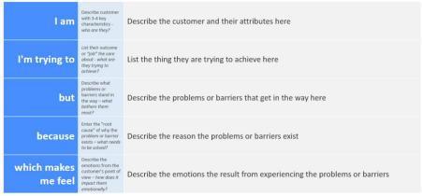

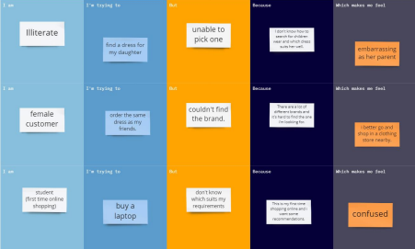

|  |  |  |  |  |  |
| --- | --- | --- | --- | --- | --- |
| **Problem**  **Statement (PS)** | **I am**  **(Customer)** | **I’m trying to** | **But** | **Because** | **Which makes me feel** |
| PS-1 | Illiterate | find a dress  for my  daughter | unable to pick one | I don't know how to  search for  children  wear and  which dress suits her  well. | embarrassing as her parent |
| PS-2 | female  customer | order the  same dress as my friends. | couldn't  find the  brand. | There are a lot of  different  brands and  it's hard to  find the one i'm lookiing for. | i better go and shop in a clothing store nearby. |
| PS-3 | student | buy a laptop | don't  know  which  suits my  requirem  ents | This is my  first time  shopping  online and i want some  recommend ations. | confused |